**Report**

**of the Union of Women of Al-Farabi KazNU**

**Exhibition of creative works "I am a Woman!"**

**Exhibition of creative works of the University staff and students**

**"I am a Woman!"**

**Organizer; Women's Council**

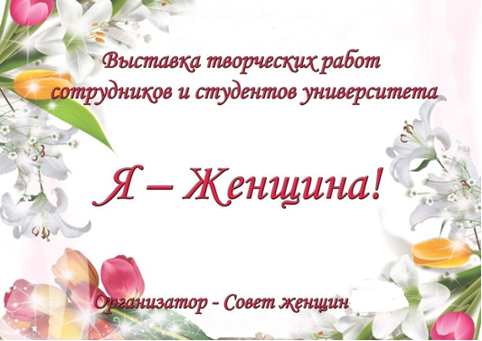

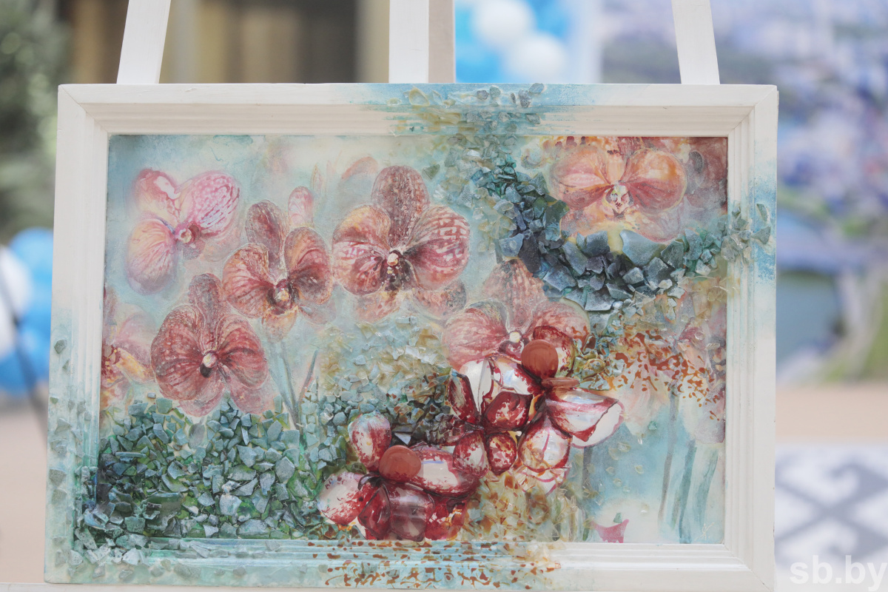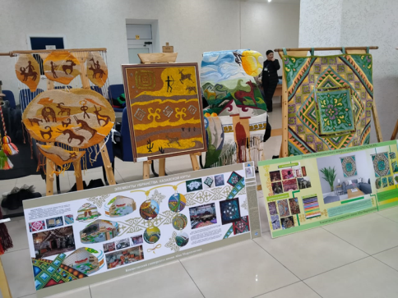

From time immemorial, our land has been famous for the art of craftswomen-needle women. It's no secret that needlework gives the opportunity to embody in life the most original ideas with their own hands. There are different kinds of needlework - knitting, crochet, embroidery, cross-stitch,cross, beads and ribbons, all sorts of techniques for making jewelry and crafts.

December 13, 2022 at the Faculty of Philology of KazNU

An exhibition of women's creative works was held at the Faculty of Philology of KazNU named after Al-Farabi. Our lovely women prepared a lot of surprises for the guests. Painting, magnificent costume jewelry, wonderful compositions from soap, paintings made of colored sand, embroidery, airy lace, wedding bouquets

The culmination of the evening was a stunning fashion show. Original outfits, presented by our wonderful models, very much liked the audience and repeatedly caused well-deserved and great applause. The exhibition was a real gift for all the women present women, in whose address the whole evening sounded congratulations, words of admiration and good wishes.